Optical mount modifications for increased articulation at the Navy Prototype Optical Interferometer

James H. Clark III∗ª, Joshua P. Walton^{b}, F. Ernesto Penado^{c}, Denver Smith^{c}
ªNaval Research Laboratory/NPOI, 10391 West Naval Observatory Road, Flagstaff, AZ, USA 86001;
^{b}Interferometrics Incorporated, 447 Lake Mary Road, Flagstaff, AZ, USA 86001;
^{c}Northern Arizona University, Department of Mechanical Engineering, Flagstaff, USA

ABSTRACT

Reconfigurations of the original optical mounts are required to facilitate the expanding capabilities and diverse science programs at the Navy Prototype Optical Interferometer. The mounts of current interest are tangent-arm gimbaled mounts located in vacuum chambers, remotely controlled, and precisely aligned through a narrow range of motion. In order to achieve the desired large changes in pathway reflections, the articulated range of the mount was increased from 4 to 45 degrees in elevation and from 4 to 90 degrees in azimuth. This increase was achieved on the elevation axis by fashioning and attaching a worm gear device, and a direct-drive type mechanism was used on the azimuth axis. The original alignment resolution and stability were preserved by retaining the high precision tangent-arm actuators. In this paper, we present the design modifications that achieved the form, fit, and function required for remote-controlled reconfiguration and alignment. The mechanical modifications, modes of operation, test results, and reconfigurations are described in detail.

Keywords: NPOI, optical mount, optical interferometry, remote control, precision alignment, vacuum system

INTRODUCTION
The Navy Prototype Optical Interferometer (NPOI)¹ has been in operation at the Lowell Observatory site on Anderson Mesa, Arizona, since 1996. An aerial view of the site is shown in Fig. 1. The interferometer consists of two integrated instruments: an astrometric array and an imaging array; both of which currently share siderostat stations and are optically compatible. The present array configuration consists of six siderostat stations²: four astrometric in fixed locations and two imaging stations that are moveable along a Y-shaped array. A maximum baseline length of 67m can be achieved. Light from each siderostat is conveyed through evacuated feed pipes and relay stations to an optics lab, where a periscope lowers the beam and directs it toward a continuously-adjustable fast delay line. The fast delay line provides from 0 to 33 meters of continuously variable optical path. The light then exits the fast delay line and proceeds to the beam-combiner where interference fringes are generated and corresponding data collected for further analysis.
In the near future, additional siderostats will be commissioned at locations further from the array center. The maximum baseline will become 97m. When the NPOI is complete, baselines up to 437m will be available. Furthermore, as the astrometric beam compressors come online, the astrometry and imaging instruments will no longer be optically compatible; two separate and distinct instruments will then share the same evacuated feed system infrastructure. To complicate matters further, additional astronomical instrumentation is being planned for the site, such as 1.4m composite optical and 1.8m infrared telescopes. In order to facilitate these expansions, long delay lines³ are required to supplement the fast delay lines. Without these long delay lines the sky coverage of the NPOI would be severely restricted. Additionally, the astrometric instrument will seldom require long delay lines. In fact they may even inhibit the performance of astrometric observations due to the introduction of additional reflections⁴. In order to enhance the performance of each observing mode (astrometric, imaging, 1.4m, 1.8m infrared, etc.), the optical path within the periscope is reconfigured accordingly. Figure 2 depicts a typical periscope layout; the left view includes the bottom half of the vacuum canister, the right half shows the periscope with the canister removed revealing the base.

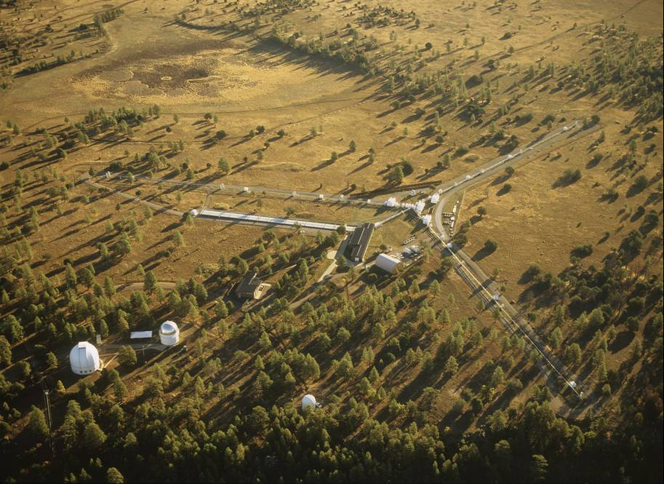

Fig. 1. NPOI site, Flagstaff, AZ (Photo courtesy of Michael Collier).

The original design layout of the NPOI does not require the periscope to be internally reconfigurable. Each of the four periscope mirrors are gently held in a tangent-arm gimbaled mount that achieves precision alignment, on the order of 200 milli-seconds of arc, through a range of approximately 4 degrees. The existing periscopes are extremely stable and require only bi-annual adjustments. It is desirable to maintain this level of precision alignment and stability following any modifications (Fig. 2).

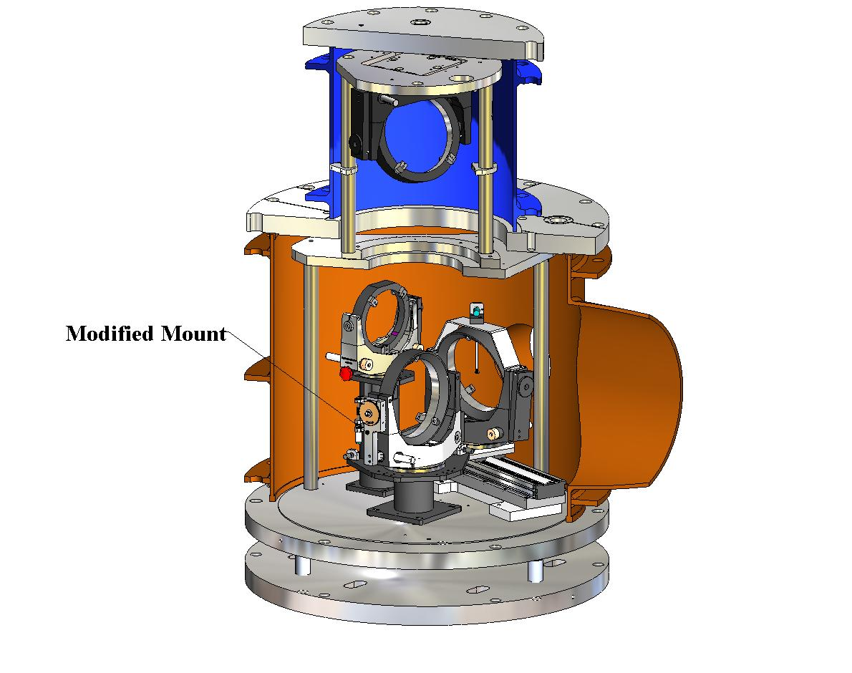
Fig. 2. NPOI Periscope configured for 1.4 meter Mode.

We can achieve the expansion of the NPOI (e.g. astrometric, imaging, 1.4m imaging, and 1.8m imaging programs, and retro-reflection) by redesigning one specific mount in the periscope. This mount must be reconfigurable to four discrete states (Fig. 3). The expansion cannot come at the expense of precision alignment, stability, or the cost of a complete redesign, fabrication, and assembly of the periscope. A search for commercially-available components yielded unsatisfactory results. Hence, we chose to modify the single mount, called the “B mirror”, as a custom-designed component. We detail the modifications to this tangent-arm gimbaled mount that yield a low drift, reconfigurable mount that retains the original precision and stability.

Fig. 3. (a) Retro-reflection mode 1, (b) Imaging Mode, (c) Astrometric Mode, (d) 1.4 meter Mode.

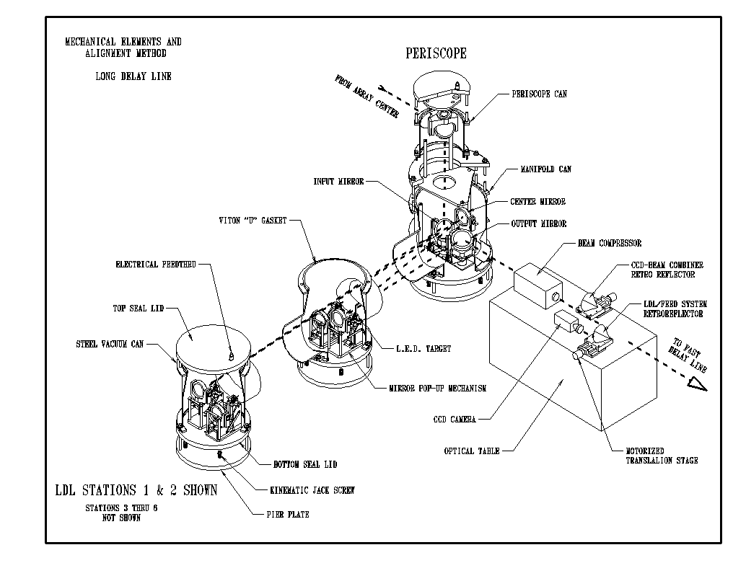
Fig. 4. Typical alignment path of a single periscope configured for imaging mode³.

TECHNICAL APPROACH
Precise alignment of the B-mirror is required at each of the four positions, in addition to retaining the original range of precision adjustment. A typical alignment path configured for an imaging configuration is shown in Fig. 4. In close proximity to the center of each mirror surface of the feed beam system is an alignment target. An alignment target consists of a 3mm diameter LED on a motorized wand. The pivot of the wand is located beyond the edge of the light beam and the wand is able to swing completely out of the light path when not in use. The alignment telescope used at the NPOI has a focus range between 0 and infinity, and an eyepiece magnification of 20x. One of the design characteristics of this telescope is that changes in focus generate negligible changes in optical path sighting. The mount for the alignment telescope is a custom v-block with 5 degrees of precision adjustment: three rotations and two translations. This mount has long term drift stability and high repeatability for multiple insertions of the alignment telescope. The alignment procedure basically consists of focusing the telescope on a target LED and adjusting the prior mirror.

Slewing of the B-mirror between the four positions is acceptable as long as the rate of slew is not so great that the LED target cannot be captured in the alignment telescope. This leads to the idea of a two-mode system for the reconfiguration and alignment of the mount: separate slew and alignment actuators. The repeatability of the four positions is dependent on the details of the stop, or stopping function of the mount, and the field of view for the particular target of interest. During reconfiguration, for example, to the 45 degree from the 0 degree position, the mount needs to stop its slew near the desired aligned state such that the target remains within the field of view of the alignment telescope. If the LED target is not in the field of view, then a dark featureless field results, culminating in a time consuming hunt-and-seek procedure. The further away the target of interest the narrower the apparent field of view, and slew rate is of primary importance. A narrowing of the field of view with distance is due to the constant diameter of the vacuum feed pipes, which are 0.2m in diameter along an entire length of a 218m arm of the array. It may be helpful to consider that we are looking through reflections in mirrors down long skinny opaque pipes, longer than a couple football fields in length, trying to see and align to a tiny 3mm diameter red light at the end. A target at the far end of an arm results in a field of view of approximately 3 minutes of arc. This requires a small range of precision alignment once the target is in view. The closer the target is to the periscope the greater the potential for an extended range of precision alignment. For example, with the target in close proximity to the aligning mirror, a large rotation is required to gain an appreciable apparent motion in the alignment telescope’s field of view, but the slew rate is not as critical for capturing the image.

A precise and reliable stop at the end of the slew mode facilitates acquiring the target automatically without resorting to a hunt-and-find routine. A target close to the periscope, say 10m distant, has a field of view of 69 minutes of arc. Although it is relatively simple to acquire the target within this larger field, subsequently it takes a relative large range of precision alignment to precisely center the target in the field. Again, the final position resulting from the slew must be within the range of the precision alignment actuator. It is thus considered that the slew stop, or stopping function, is critical when using separate actuators for precision alignments and slew functions. The existing NPOI precision alignment is quite adequate and needs no alteration. We chose to simply modifying the mount to accept an additional slew actuator with precision stop to increase the articulation range of the mount.

2.1 Elevation Axis Worm Gear

A simple modification to the tangent arm and axle design allow the incorporation of a worm gear system for the slewing function, retaining the tangent-arm precision alignment in its original condition. Noting that the plane of the mirror surface and elevation axis is nominally collinear, an imbalance exists about this axis due to the mass of the mirror being located behind the axis. This can be used advantageously since the resultant back-weighting of the mirror cell causes a pre-loading on the worm gear. The worm gear and worm were chosen such that back-driving cannot occur. Hence, a subsequent clamp or locking mechanism is not required to retain the mirror in the proper position, which is either vertical or at a 45 degree angle. All periscope mounts and actuators reside in permanent vacuum, are remotely controlled, and are unavailable for casual maintenance. Thus, the fewer electrical components, such as actuators, clamps, encoders, micro-switches, etc., the more reliable the system. For a general comparison between the unmodified and modified 8-inch gimbaled mount see Fig. 5 and 6.

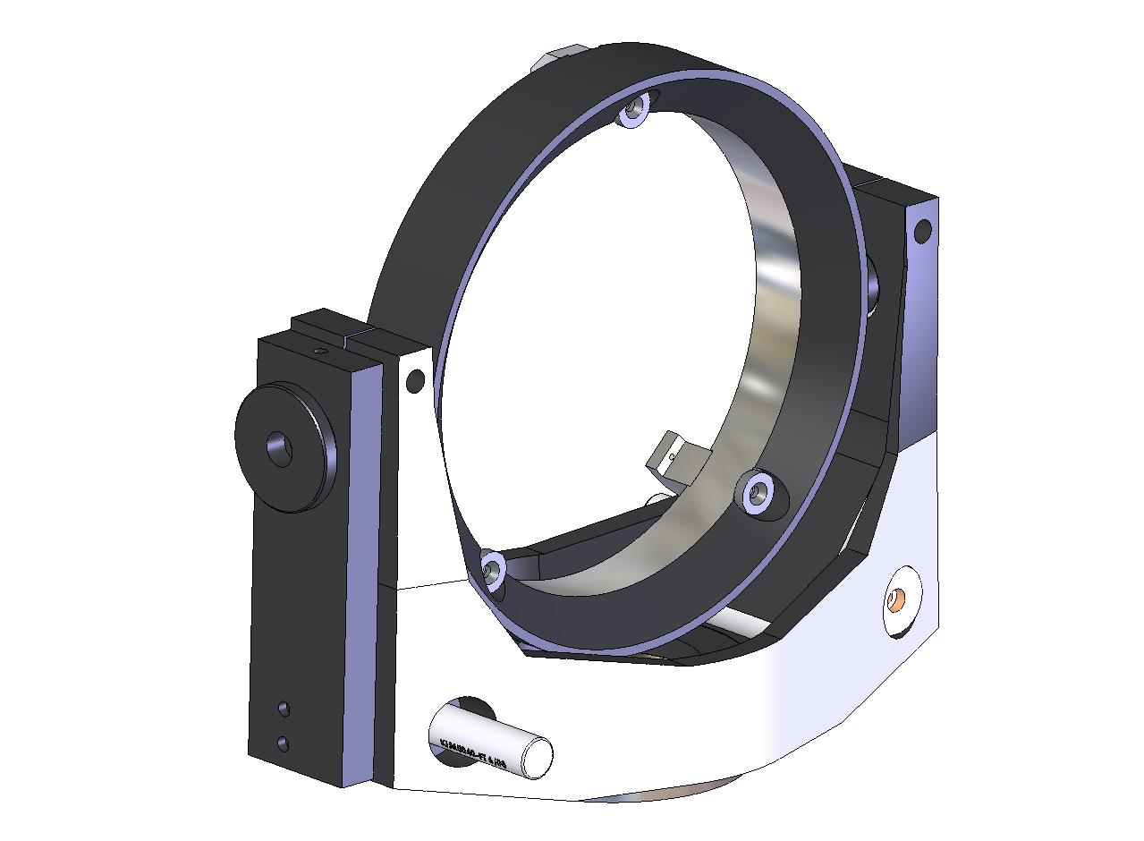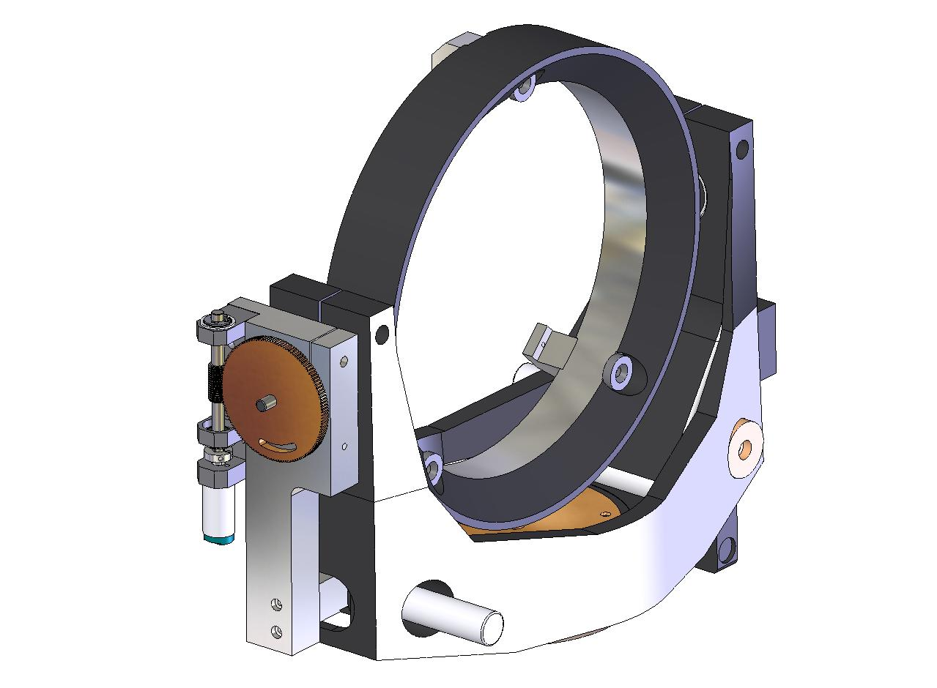

Fig. 5. Unmodified Gimbaled Mount. Fig. 6. Modified Elevation Axes.

A stop-pin protruding from the elevation tangent arm and an arced groove machined in the worm gear provide the precision hard stop for slew mode (Fig. 7). The precise locations of the ends of the machined groove provide the precision of the final pointing location of the mirror at the end of a slew run. As the worm gear rotates so does the mirror, and the groove eventually comes close to the stationary pin. As contact is made between the end of the groove and the pin, the direct-current motor driving the worm draws more electrical current until motor stall occurs. Adjustment of the stall-current of the motor controller is made such that minimal mechanical spring-back occurs when the motor is shut off. This results in a final positioning of the mirror to within the specifications resulting from the field of view requirements. We found for our system that a groove dimension resulting in slightly more (approximately 15 minutes of arc) than the required forty five degree articulation range, gave excellent results since we could always see the target go through the center of the field of view. The slew rate is not greater than the target image capture rate. Once a slew completes, the target remains in the field of view, and the precision alignment actuators bring the system into final alignment. Creep of the precision range of motion toward one limit over another cancels out.
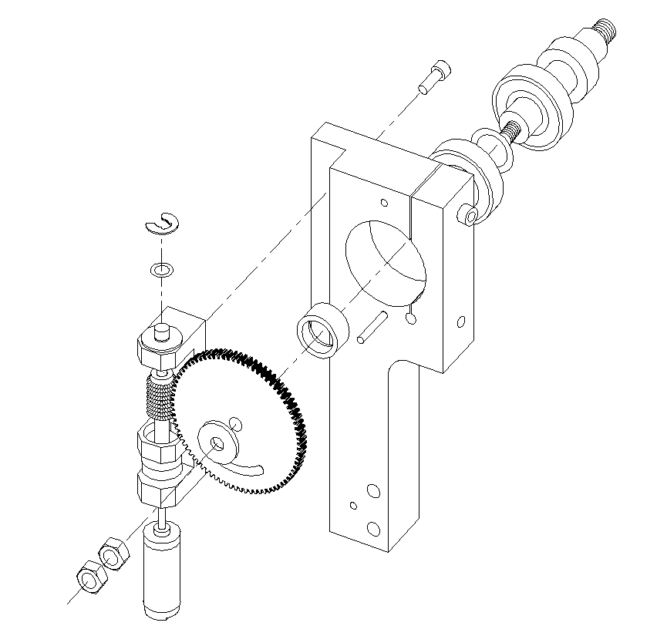
Fig. 7. Exploded view of worm drive.

2.2 Azimuth direct drive

We chose a direct drive slew system incorporating hard-stops for increasing the articulated range in the azimuth axis. As in the approach to the elevation axis modification, the original tangent-arm precision alignment design and actuators, which have proven to be successful in the current build of the NPOI, remain unchanged. For the same reasoning as discussed above, it is the resulting resting position of the mirror at the end of a slew that is important. Precision needs to be maintained at the ends of a slew in order to accommodate both the field of view and range of precision alignment requirements. Hard stops, combined with a motor current-limiter, seem to be perfectly adequate and require no limit switches, encoders, or other monitoring or metrological devices which may complicate the system rendering it less reliable and more expensive. The direct-current drive motor is housed inside the pedestal mount and is not an integral part of the gimbaled mount as is the elevation drive (Fig. 8). Since there is no preexisting natural preload due to gravity or some other force or an anti-back drive device in the azimuth axis, utilizing the same current limit technique described above, must be accompanied with a remote controlled clamp (i.e. locking mechanism). The clamp is activated prior to shut off of the drive motor. The motorized clamp was achieved by simply replacing the manual azimuth clamp with a motorized screw; the same type of motorized screw as the precision actuators was employed as this made the electrical connections and controls similar. The hard stops are located on an interface plate sandwiched between the base of the gimbaled mount and pedestal. They are located such that 90 degrees of rotation occur for the azimuth axis. The stops are hardened ball-tipped screws which are adjustable during the assembly phase allowing for slight variations in the fabrication process. Stop-tabs with hardened buttons are fashioned to the gimbaled mount and make contact with the stop-screws at the end of the slew process (Fig. 8).
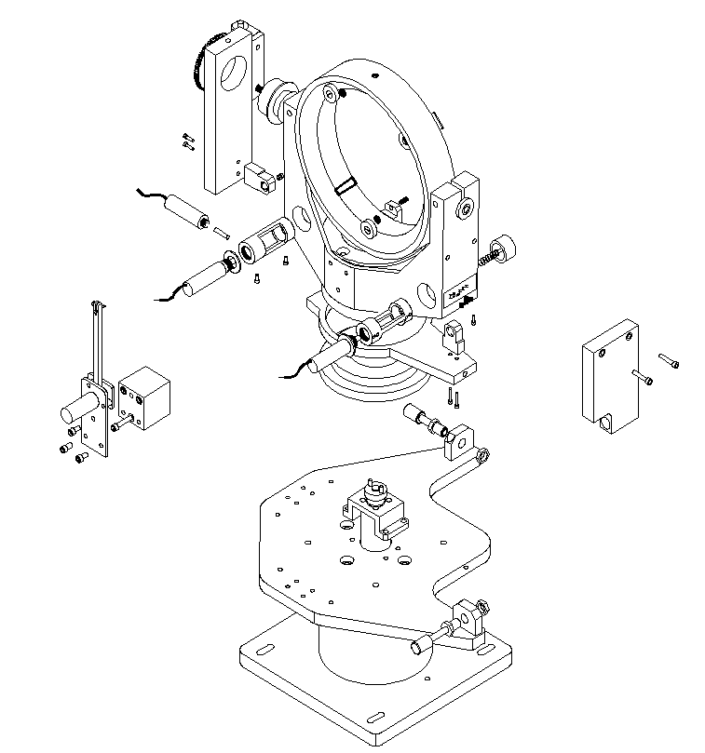
Fig. 8. Azimuth direct drive in pedestal.

TESTS AND RESULTS
3.1 Form, fit, and function

Prototype modifications and assembly were conducted to determine form, fit, and function of the newly modified gimbaled mount (Fig. 10 and 11). The form and fit of the device is as expected with no mechanical interferences or obvious vignetting of a five inch diameter light beam. This was determined by assembling a full scale prototype periscope base on a laboratory bench, comparing its geometry to the CAD model by measuring critical dimensions with a steel rule, manually reconfiguring (rotating and sliding) all the mirror mounts, and performing a visual bore-sighting down the optical path. The steel rule measurements indicate excellent comparison with the CAD specifications. Manual reconfigurations such as rotations in elevation and azimuth, inserting and stowing the LED targets, and generally trying to find positions and/or a procedure that would create a crash or binding of the assembly, indicate a well laid out system free of jamming scenarios. This is important because the final periscope system resides under continuous vacuum conditions, behind opaque steel canisters, and casual maintenance is nonexistent. Bore-sighting revealed no inadvertent protrusions into the light path which may cause vignetting. The LED targets appeared to be located in the proper position. These are slightly adjustable during the final commissioning alignment, contain sufficient adjustment range, and properly tuck out of the light path in the stow position. Functionality was determined empirically on the prototype assembly. The elevation worm drive, azimuth direct drive, and azimuth clamp were operated using a standard direct-current power supply. All three actuators operated smoothly with the expected nominal amperages draw between 200 and 300 milli-amperes. Stall currents were nominally 300 to 600 milli-amperes (depending on the particular motor size). All three actuators continued to operate smoothly when the supply voltage was reduced, 2 volts at a time, from 12 volts, down to 4 volts. The final operating voltage and current limit are set during the commissioning assembly phase in order to minimizing spring-back loading, which alters the final alignment once power to the actuator motor is turned off.

3.2 Vibration

Vibration tests were performed on the modified tangent-arm gimbaled mirror mount in order to determine if any severe degradation in stiffness or stability of the mount had been introduced. The testing was performed by attaching the three mirror mounts to the prototype periscope base as in the tests for form, fit, and function. An unmodified control mount was fitted with an aluminum mirror blank which had very nearly the same mass as a glass mirror (within 2%). The modified mount was fitted with an uncoated glass mirror. All data was gathered using a three-axis Endevco accelerometer with a sensitivity of 100.8 mV per G of acceleration. The data was processed using Lab View 8.2 which provided a voltage reading and power spectrum of each axis. The periscope base plate was floated on an optics table to reduce the effects of outside vibrations such as those transmitting through the laboratory floor.

The base plate and mirror mounts were measured with the accelerometers for a period of two minutes in order to gather a baseline measurement. An impact was then applied to the plate and mounts through a pendulum. This induced the vibration spectrum within the mount of interest. The system was then allowed to return to the baseline. The data was recorded and later analyzed for first peak and frequency, maximum peak and frequency, and time to return to baseline. Nine impacts were performed for each set up. All baselines fell within a range of 75 to 67.5 dB. There was no difference noted between the baselines of any setup. The control mount and the modified mount when set to 45º averaged 9.8 and 9.6 seconds settling time, respectively (Table 1.). The modified mount when set to 90º took 10.3 seconds. The peak value was the lowest for the control set up and increased slightly with the others, with the base plate having the greatest value. The frequencies for all of the peak values typically fell between 200 and 300 Hz. The first peak value had the same trends as the maximum peak value but less of a change from the baseline. The frequency for the modified mount did however increase over both the base plate and control set up. From analysis of the design, vibrational restrictions will ultimately come from the base plate and not the modified mount.

Table 1. Vibration test results.
Case | Average Settling Time (seconds)
Control Mount @ 90° | 9.83
Modified Mount @ 90° | 10.32
Modified Mount @ 45° | 9.63

3.3 Repeatability and drift

A prototype mount with the elevation worm drive system was installed in a working evacuated periscope. Preliminary tests were performed for retro-reflection repeatability over several cycles and with drift stability over a period of one day. During the repeatability tests it was found that after a slew, the LED target located approximately 200 meters distant returned each time within the field of view of the alignment telescope. Since the field of view at this distance is on the order of three minutes of arc, it can be claimed, therefore, that the elevation worm drive system appears to repeat at a level no worse than three arc-minutes. Drift stability was determined by monitoring a laser beam metrology system. This metrology system is an inherent component of the astrometric instrument and measures changes in path length along the feed beam relay system. With the test mount set in retro-reflection mode, the metrology laser beam was returned to its source, completing the circuit. Longitudinal drifts, along the optical axis, in a train of relay mirror mounts are detected as a change in path length; angular rotational drifts are exhibited as a reduction in signal strength. It is the observation of signal strength reduction that indicates a relative stability in these preliminary tests. All we can say at the time of this writing is that the metrology signal is quite sensitive to angular changes in alignment, and over a period of approximately twenty four hours the strength of the metrology signal was not reduced noticeably. This has led us to believe we have excellent stability in the mount.

CONCLUSIONS AND DISCUSSION
Reconfiguration of the light paths at the NPOI have been accomplished by increasing the articulation range of a single mirror mount within the periscope. The original precision adjustments are retained. By employing two separate actuators for slew and precision alignment, incorporating hard stops and motor current limiting functions, and modifying the elevation and azimuth axes accordingly, it has been found that not only the form, fit, and function of the modified periscope is successful, but has been accomplished relatively inexpensively. Tests performed within the actual evacuated feed beam system indicate the repeatability in elevation is well within the required 3 minutes of arc. By retaining the original tangent-arm precision alignment system no degradation in final alignments or tweaking were identified. The slew rate during a reconfiguration is slow enough to capture the target and stop the slew such that the target remains in the field of view for subsequent precision alignment. Preliminary laser metrology tests conducted for drift measurements, though rather qualitative, indicate stability comparable to the unmodified tangent-arm gimbaled mounts; no apparent degradation in stability was caused by the modifications. To date, both the repeatability and drift tests indicate a satisfactory modified mirror mount system. Furthermore, the retrofit of the single gimbaled mount requires many less man hours when compared to a complete redesign of the periscope since the basic alignment of the three other mirror mounts needs little or no disturbance.

ACKNOWLEDGEMENTS

The authors thank the Oceanographer of the Navy and the Office of Naval Research for support of the Navy Prototype Optical Interferometer. Additionally, this work could not have been completed without the CAD expertise provided by Long Ky Ha and James Darwin.

REFERENCES

- J. T. Armstrong, D. Mozurkewich, L. J. Rickard, D. J. Hutter, J. A. Benson, P. F. Bowers, N. M Elias II, C. A. Hummel, K. J. Johnston, D. F. Buscher, J. H. Clark III, L. K. Ha, L.-C. Ling, N. M. White, and R. S. Simon, “The Navy Prototype Optical Interferometer,” Astrophysics. J. 496, pp. 550-571, 1998.
- J. A. Benson, C. A. Hummel, and D. Mozurkewich, “Simultaneous 6-station observations with the NPOI,” Proc. of SPIE, Vol. 4838, 2003 SPIE-0277-786X/03, 2003.
- J. H. Clark III, L. Ha, D. Mozurkewich, and J. T. Armstrong, “Design of the long delay lines for the Navy Prototype Optical Interferometer,” in Astronomical Interferometry, R.D. Reasenberg, ed., Proc. SPIE 3350, pp. 497-504, 1998.
- J. H. Clark, III, J. Murphy, L. Ha, J. P. Walton, J. Howard, J. T. Armstrong, G. C. Gilbreath, R. B. Hindsley, and T. A. Pauls, “Optical drift test of the long delay line stations on the Navy Prototype Optical Interferometer”, in New Frontiers in Stellar Interferometry, Proc. SPIE AS04-AS03-137, 2004.

 jhc@sextans.lowell.edu; phone 1 928 779-5132; fax 1 928 774-3626

